FANS-DETAILS ACCORDING TO THEIR TYPES

1. *Table Fans*

*color:several colors available*

*Matrial:Plastic|metal*

*Price:according to brand*

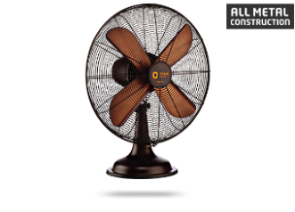

RETRO-T16



Green-Carnation

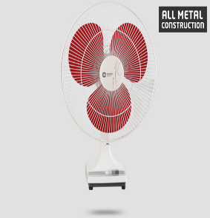

deluxe-supreme

*2.Ceiling fans*

*Most of them work silently*

*Available in stunning color combinations*

*Most of them are high speed*

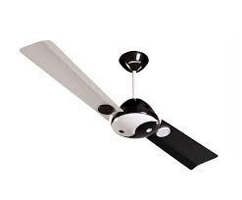

Couplet

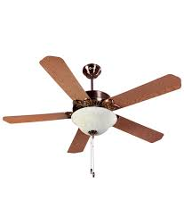

Subaris

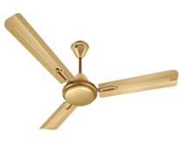

Ecoquasar

*3. Industrial & Blowers Fans*

*They are machines whose primary function is to provide and accommodate a large flow of air or gas to various parts of a building or other structures*

*This is achieved by rotating a number of blades, connected to a hub and shaft, and driven by a motor or*[*turbine*](https://en.wikipedia.org/wiki/Turbine)*.*

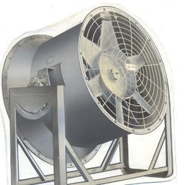

Wall mounting bracket

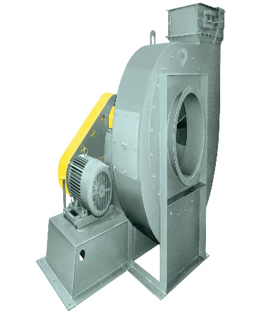

centrifugal blower

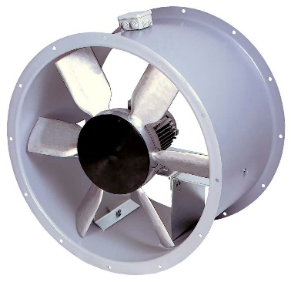

Joist Hanger Bracket

*4. Wall Mount Fans*

*Portable***Fans***.*

**Wall mounted***oscillating***fans.**

*Mount to the wall for safe and out-of-the-way operation.*

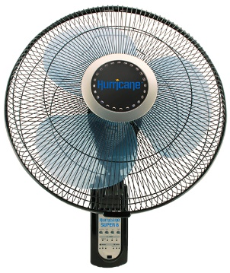

Hurricane-Super-8

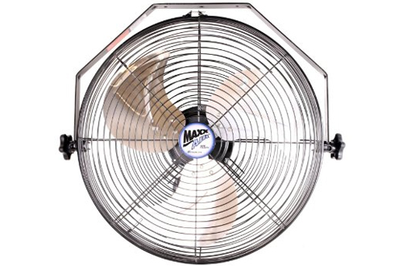

MaxxAir-HVWM18

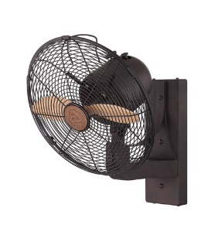

Savoy-House-12

*5. Windows Fans*

*A****window fan****is a*[*fan*](https://en.wikipedia.org/wiki/Fan_(mechanical))*designed to be placed inside the frame of a*[*window*](https://en.wikipedia.org/wiki/Window)*. Window fans have been used for many decades to maintain*[*comfortable temperatures*](https://en.wikipedia.org/wiki/Room_temperature)*and*[*ventilation*](https://en.wikipedia.org/wiki/Ventilation_(architecture))*within one's home, and operate at a tiny fraction of the cost of central air conditioning.*

*Most window fans have two or three speeds, and some are electrically reversible so that the user can switch between intake and exhaust modes*.

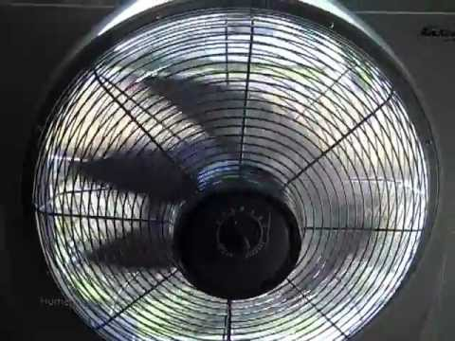

Airkingwholehouse

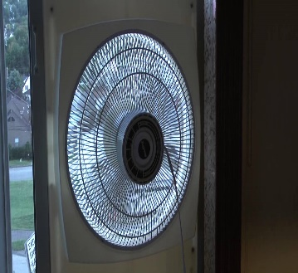

Airkingmodel

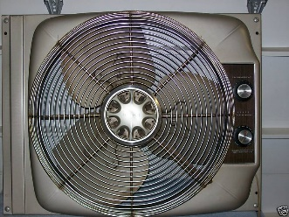

Sears 480

*6. Tower Fans*

*Tower fans are great living room companions. They aren’t quite an air conditioner, but they provide a blast of cool air in otherwise hot conditions that can help make you comfortable.*

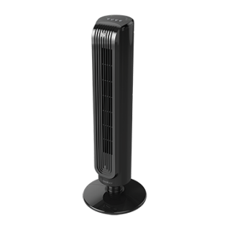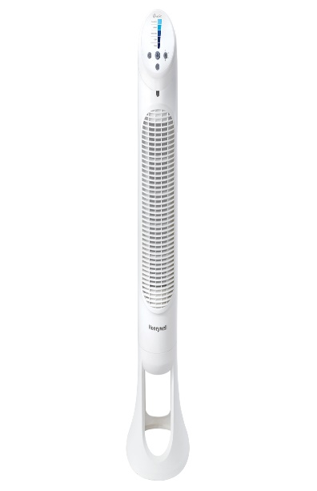HoneywellHYF260W

LaskoT32200

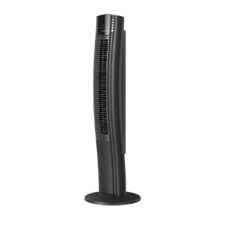

LaskoT42915

*7. Decorative Fans*

*Decorative fans can be any other type only that they are used for decoration.*

*They may have different colors to add beauty to the fan.*

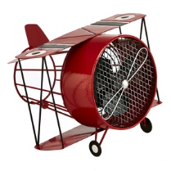

Biplane

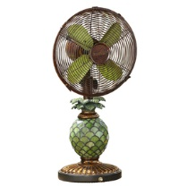

Pineapple

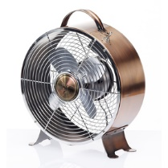

Retro

*8. Floor Fans*

*We have different types of floor fans.*

*There are industrial floor fans and also standalone floor fans.*

*Most of the floor fans uses the optimized blade structure, have low noise and large air volume.*

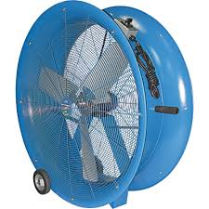 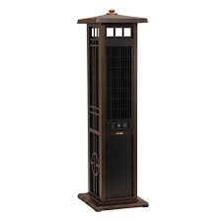 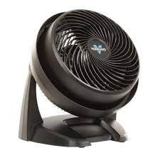

***9. Misting Fans***

***They are mostly used outdoors***

*Misting fans combine an outdoor fan with mist cooling provided by water from a tank or hose. They can reduce dust and odors in the area, as well as static electricity and the presence of flying insects. They can help regulate humidity, but most of all, they can cool you off.*

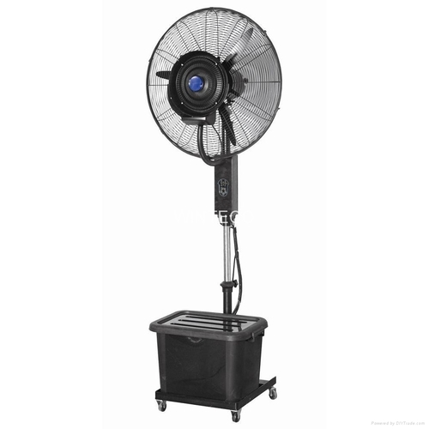 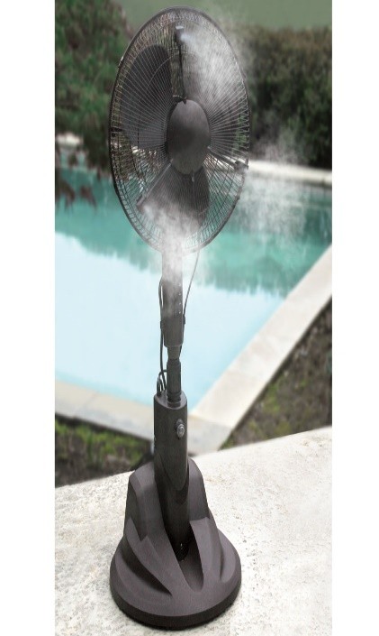 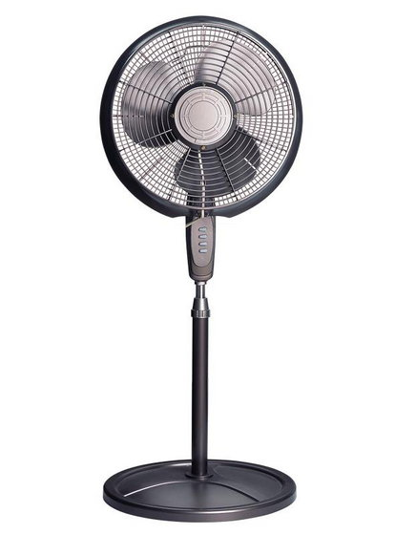

***10. Box Fans***

*• Mounts in a square cutout and conceals the hole-cut to simplify installation work.*

*• Cover can be set to open either upward or downward for convenience in confined spaces.*

*• Enhanced accessories (finger guard, filter, plug cord, mounting screws).*

*• Optional Replacement Filter and Vent Attachment.*

*• The lineup includes Single, Double, and Triple Box Fans with eight models with plastic blades and eight models with metal blades.*

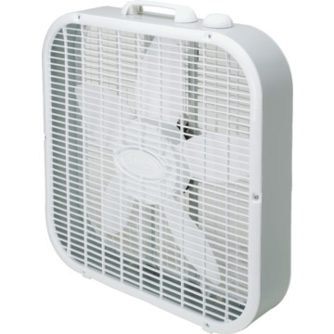 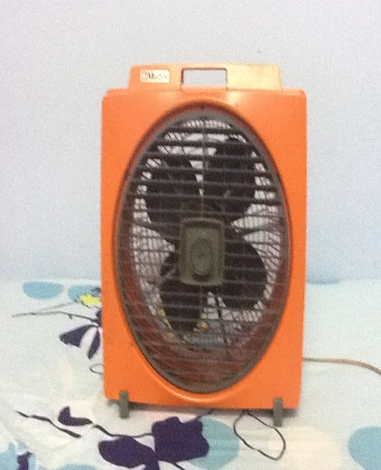 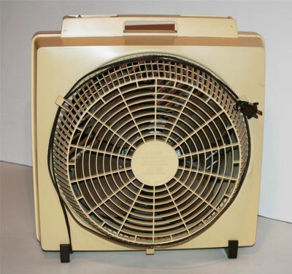

***11. Bathroom Exhaust Fans***

*Bathroom fans are in-wall or in-ceiling exhaust fans designed to add ventilation, improve airflow, and reduce excess humidity. Technically, these systems remove warm moisture from your bathroom and exhaust it outdoors through your home's ductwork. Using a fan helps prevent mold and mildew problems, maintain healthier indoor air quality, and keeps you safe and comfortable*

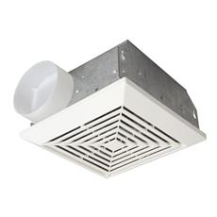

Craftmade-TFV70

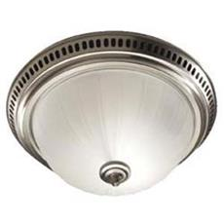

Nutone-741SNNT

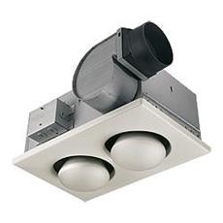

Nutone-9427P